**SUB-PROCESS**

**In order to reduce the complexity in view of a BPD/Process we go for sub-process.**

**Sub-process is not reusable.**

**Sub-process won’t have data mapping.**

**Step1: if your BPD is having dis many activities, we can use sub-process instead of it.** 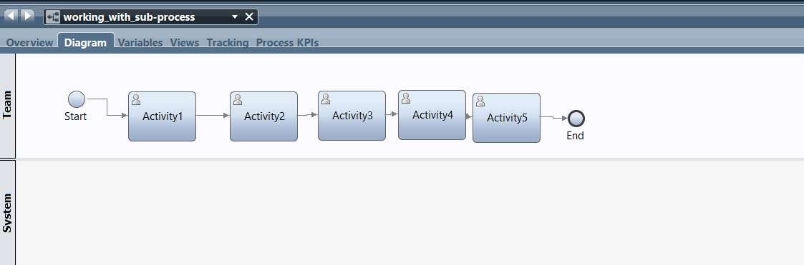

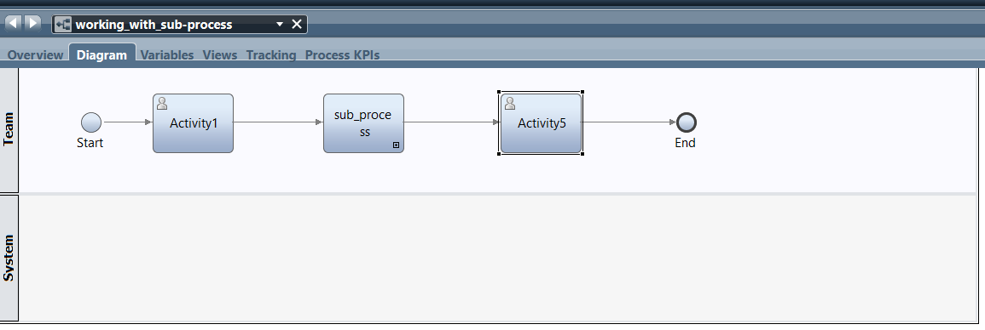

**Step2: In sub-process I have added the activities.**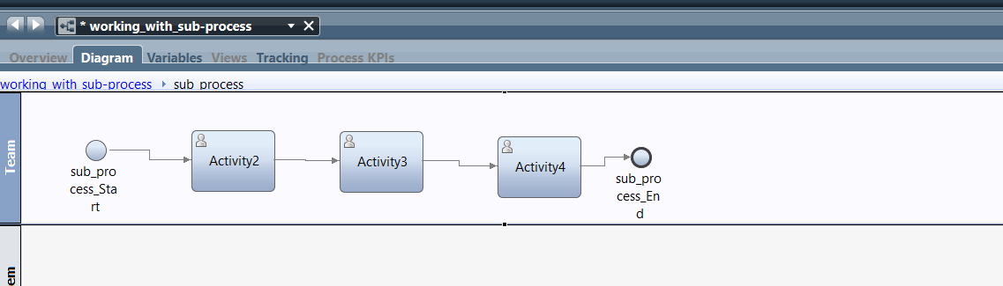

**Step3: The variables which we are created in parent process, we can use it in child process.**

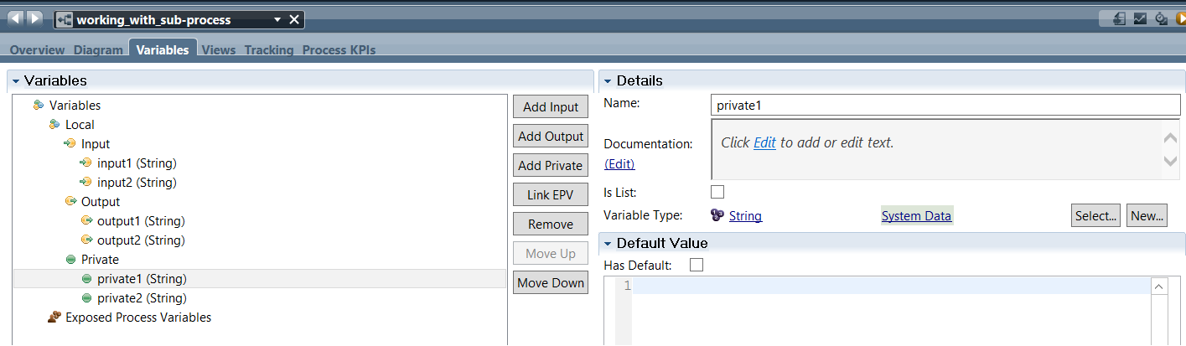

**Step4: we can create only private variables in sub-process, but it is not accessible in parent process.**

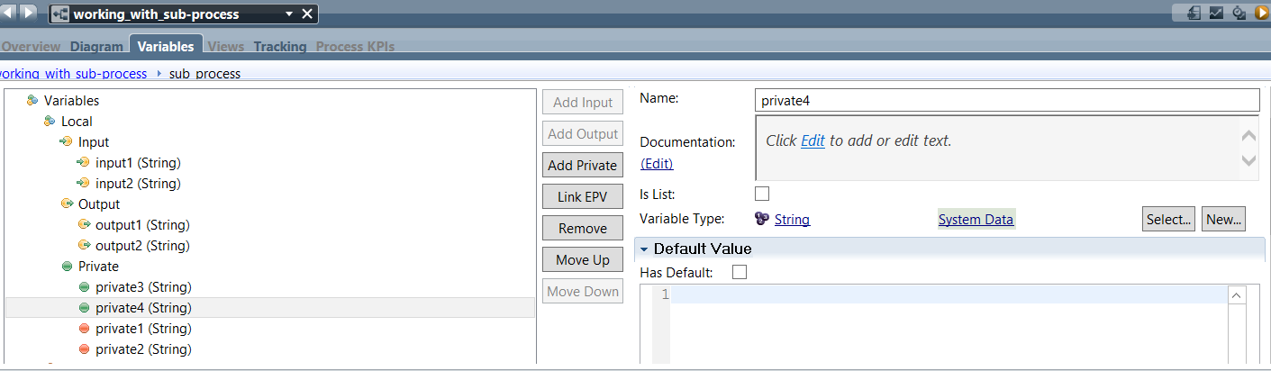

**Step5: Here we can see, the private variables which we are created in child is not showing in parent process.**

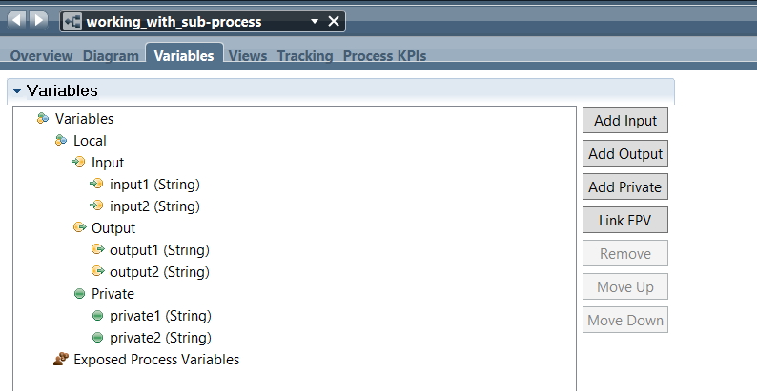

**Step6: In parent process if we link epv, it will not show in child process.** 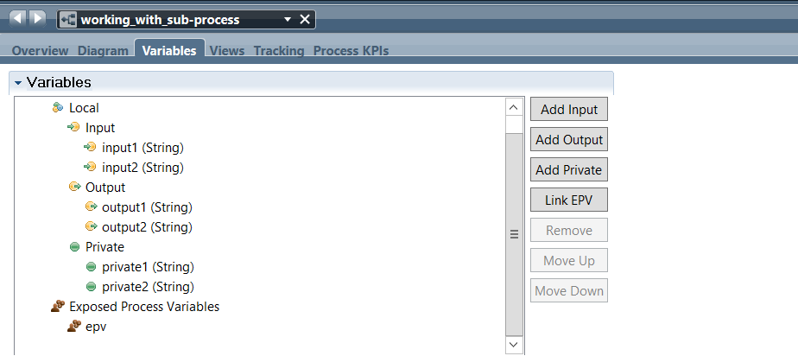

**Step7: Here we can see, the linked epv is not visible in child process.** 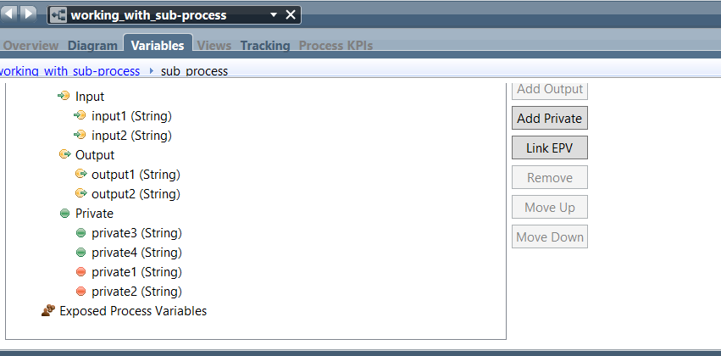

**Step8: In child process if we link epv, it will not show in parent process.**

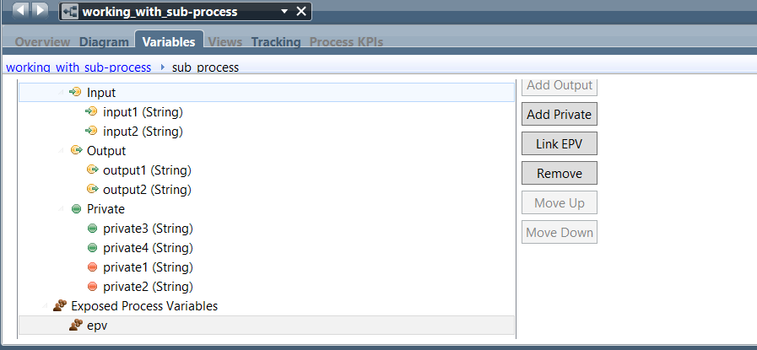

**Step9: Here we can see, the linked epv is not visible in parent process.**

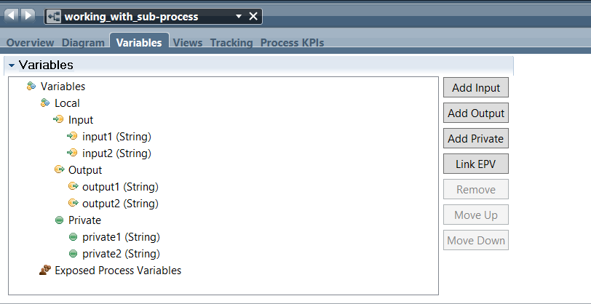

**Step10: The token will be moved from one to one like this.**

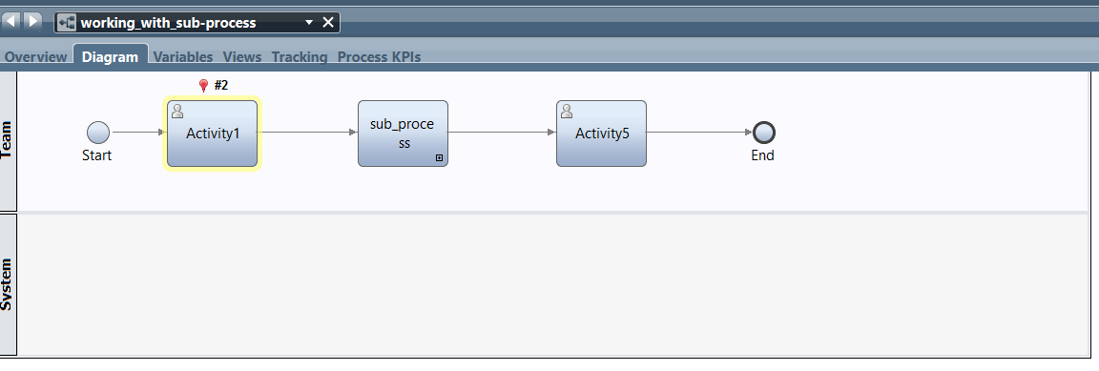

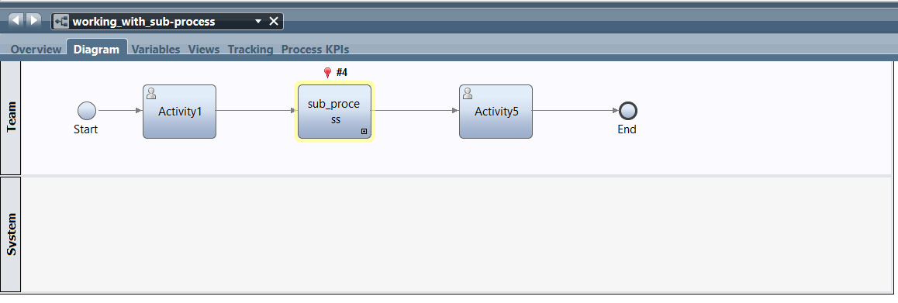

**Step11: you can see the activities, finished one by one.**

